Number blocks 2
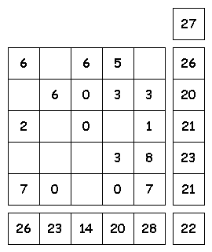
Try to fill in the missing numbers.
The missing numbers are integers between 0 and 9.
The numbers in each row add up to totals to the right.
The numbers in each column add up to the totals along the bottom.
The diagonal lines also add up the totals to the right.

